Affidavit in Support of Protection Against Deportation of Ndip Otun Etta to Uganda as a Third Safe Country
I, Asubola Jamidah, a citizen of Uganda, respectfully submit this affidavit to the Immigration Judge regarding the issue of deporting foreign nationals and Ndip Otun Etta in particular from the United States to Uganda as a third safe country. I wish to bring to the court's attention the severe political instability, discrimination, and ongoing human rights abuses in Uganda, which make it an unsafe destination for deportees.
In recent years, Uganda has witnessed extreme political repression under President Yoweri Museveni's regime. Political opposition is met with violent crackdowns, arbitrary arrests, and torture of those who oppose the government. The security forces routinely use excessive force against peaceful protesters and critics, with little to no accountability. Torture and ill-treatment of detainees are widespread, and there are credible reports from both Amnesty International and Human Rights Watch documenting the abuse of political prisoners, journalists, and opposition members.
Moreover, foreign nationals, particularly those from marginalized or dissenting backgrounds, face significant discrimination, harassment, and risk of arbitrary detention. Uganda’s government has been known to target individuals based on their national origin or political views, further exacerbating the danger for deportees.
In this context, I urge the court to consider the positions taken by U.S. Senators such as Dick Durbin and Patrick Leahy, who have voiced opposition to sending individuals back to Uganda due to the country's human rights violations. As such, deporting foreign nationals to Uganda is both dangerous and unjust.
Respectfully submitted,
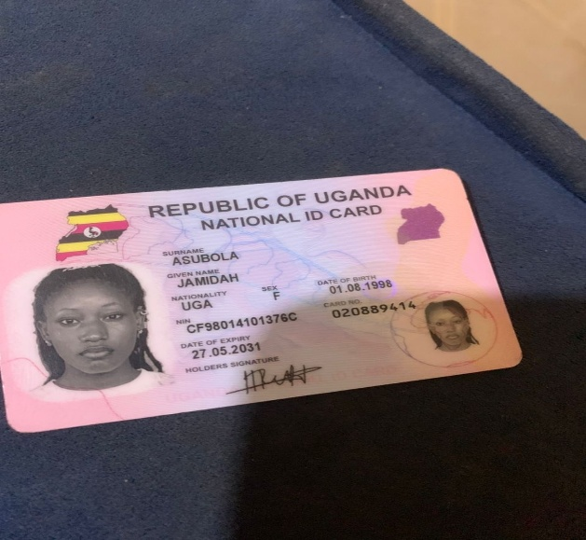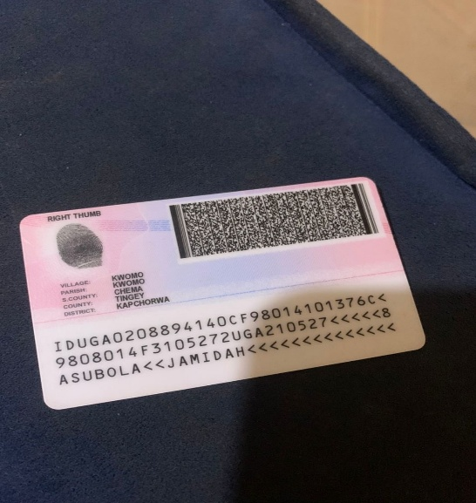
Asubola Jamidah,
28 January 2026

